Are you thirsty for something more satisfying in your life?
Jesus said, “I will be a well of water for you.”

John 4:3-30: He left Judea and departed again to Galilee. But He needed to go through Samaria. So He came to a city of Samaria which is called Sychar, near the plot of ground that Jacob gave to his son Joseph. Now Jacob’s well was there. Jesus therefore, being wearied from His journey, sat thus by the well. It was about the sixth hour. A woman of Samaria came to draw water. Jesus said to her, “Give Me a drink.” For His disciples had gone away into the city to buy food. Then the woman of Samaria said to Him, “How is it that You, being a Jew, ask a drink from me, a Samaritan woman?” For Jews have no dealings with Samaritans. Jesus answered and said to her, “If you knew the gift of God, and who it is who says to you, ‘Give Me a drink,’ you would have asked Him, and He would have given you living water.” The woman said to Him, “Sir, You have nothing to draw with, and the well is deep. Where then do You get that living water? Are You greater than our father Jacob, who gave us the well, and drank from it himself, as well as his sons and his livestock?” Jesus answered and said to her, “Whoever drinks of this water will thirst again, but whoever drinks of the water that I shall give him will never thirst. But the water that I shall give him will become in him a fountain of water springing up into everlasting life.” The woman said to Him, “Sir, give me this water, that I may not thirst, nor come here to draw.” Jesus said to her, “Go, call your husband, and come here.” The woman answered and said, “I have no husband.” Jesus said to her, “You have well said, ‘I have no husband,’ for you have had five husbands, and the one whom you now have is not your husband; in that you spoke truly.” The woman said to Him, “Sir, I perceive that You are a prophet. Our fathers worshiped on this mountain, and you Jews say that in Jerusalem is the place where one ought to worship.” Jesus said to her, “Woman, believe Me, the hour is coming when you will neither on this mountain, nor in Jerusalem, worship the Father. You worship what you do not know; we know what we worship, for salvation is of the Jews. But the hour is coming, and now is, when the true worshipers will worship the Father in spirit and truth; for the Father is seeking such to worship Him. God is Spirit, and those who worship Him must worship in spirit and truth.” The woman said to Him, “I know that Messiah is coming” (who is called Christ). “When He comes, He will tell us all things.” Jesus said to her, “I who speak to you am He.” And at this point His disciples came, and they marveled that He talked with a woman; yet no one said, “What do You seek?” or, “Why are You talking with her?” The woman then left her waterpot, went her way into the city, and said to the men, “Come, see a Man who told me all things that I ever did. Could this be the Christ?” Then they went out of the city and came to Him.

The Fountain of Eternal Life
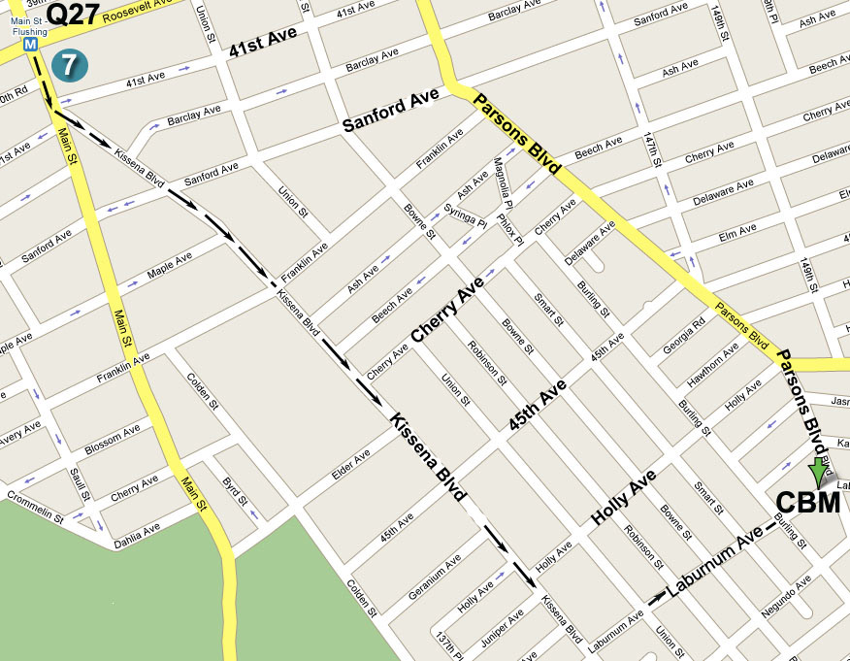
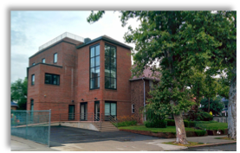
“But whoever drinks of the water that I shall give him will never thirst. But the water that I shall
give him will become in him a fountain of water springing up into everlasting life.” - John 4:14
2019 Spring Gospel Meeting in Flushing

Time: 2019-03-31, Sunday morning 11:00AM
Place: Christian Believers’ Meeting
146-29 Laburnum Avenue,
Flushing, NY 11355
Phone: 845-824-9999

