The Fountain of Eternal Life
永生的泉源
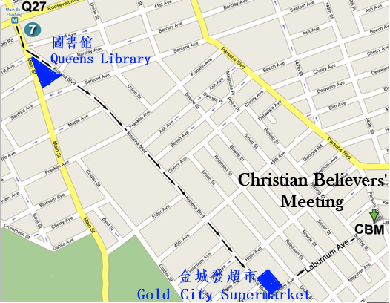
Jesus is the “I am.”
He is all that you will ever need.
Are you spiritually hungry?
He said, “I am the bread of life.”
Are you thirsty for something more satisfying in your life?
He said, “I will be a well of water for you.”
Are you afraid of death?
He said, “I am the resurrection and the life.”
Are you weary and heavy-burdened?
He said, “I will be your rest.”
Are you confused about life and don't know your way?
He said, “I am the way, the truth, and the life.”
Are you in the dark about what life is about?
He said, “I am the light of the world.”

耶穌說：我是！
祂是你永遠所有的需要。
你是否觉得心中的空虚无法满足？
耶穌說，“我是生命的糧。”
你是否心靈乾渴？
耶穌說：“我將成為你生命中活水的泉源。”
你是否畏懼死亡？
耶穌說：“我是復活和生命。”
你是否疲倦和不堪重負？
耶穌說，“我將是你的安息。”
你是否對生活感到困惑，不知道你的方向？
耶穌說，“我就是道路，真理，生命。”
你是否發現你在黑暗中不知生活為了什麼呢？
耶穌說，“我是世界的光。”

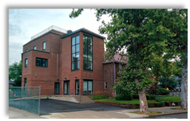
“But whoever drinks of the water that I shall give him will never thirst. But the water that I shall
give him will become in him a fountain of water springing up into everlasting life.” - John 4:14
人若喝我所賜的水就永遠不渴。我所賜的水要在他裡頭成為泉源，直湧到永生。
-約翰福音4:14
2019 Spring Gospel Meeting in Flushing
法拉盛地區2019年春季福音聚會

Time/日期: 2019-03-31, Sunday禮拜天上午11:00AM
Place/地點: Christian Believers’ Meeting
146-29 Laburnum Avenue,
Flushing, NY 11355
Tel/電話: 845-824-9999

