Christ, the Wisdom of God
基督，神的智慧
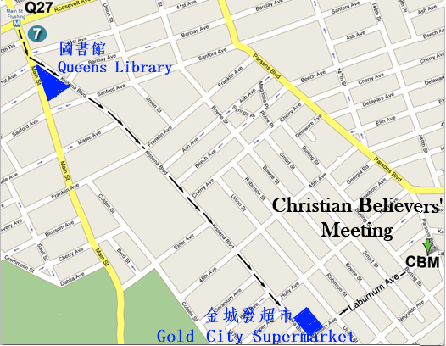
Jesus is the “I am.”
He is all that you will ever need.
Are you spiritually hungry?
He said, “I am the bread of life.”
Are you thirsty for something more satisfying in your life?
He said, “I will be a well of water for you.”
Are you afraid of death?
He said, “I am the resurrection and the life.”
Are you weary and heavy-burdened?
He said, “I will be your rest.”
Are you confused about life and don't know your way?
He said, “I am the way, the truth, and the life.”
Are you in the dark about what life is about?
He said, “I am the light of the world.”

耶穌說：我是！
祂是你永遠所有的需要。
你是否觉得心中的空虚无法满足？
耶穌說，“我是生命的糧。”
你是否心靈乾渴？
耶穌說：“我將成為你生命中活水的泉源。”
你是否畏懼死亡？
耶穌說：“我是復活和生命。”
你是否疲倦和不堪重負？
耶穌說，“我將是你的安息。”
你是否對生活感到困惑，不知道你的方向？
耶穌說，“我就是道路，真理，生命。”
你是否發現你在黑暗中不知生活為了什麼呢？
耶穌說，“我是世界的光。”

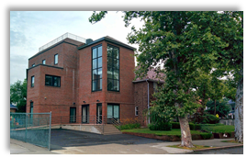
For since, in the wisdom of God, the world did not know God through wisdom, it pleased God through the folly of what we preach to save those who believe.
1 Corinthians 1:22
世人憑自己的智慧，既不認識 神，神就樂意用人所當作愚拙的道理，拯救那些信的人
-哥林多前書1:22
2017 Fall Gospel Meeting in Flushing
法拉盛地區2017年秋季福音聚會

Time/日期: 2017-11-05, Sunday禮拜天上午11:00AM
Place/地點: Christian Believers’ Meeting
146-29 Laburnum Avenue,
Flushing, NY 11355
Tel/電話: 516-234-0868

