**It is Harvest time**

***There is a great harvest coming upon the earth***

Revelation 14.15 And another angelcame and cried with a loud voice, “ Put in your sickle and reap, for the hour to reap has come, because the **harvest** of the earth is ripe.”

***Whatever a man has sown he shall reap***

Galatians 6.7 Be not deceived; God is not mocked: for whatsoever a man **soweth**, that shall he also **reap**.

***To the one who sows the seeds of sin, judgment is his harvest***

Proverbs 22.8 He that **sows** sin shall **reap** only weeds and trouble

***The one who sows with tears of repentance shall rejoice at God’s Harvest***

Psalms 126.6 He who goes out weeping, carrying seed to **sow**, will return with songs of joy, carrying his **sheaves**.

***The Harvest is coming. The Summer of sin is over. Are you saved?***

Jeremiah 8.20 “The **harvest** is past, the summer has ended,

and we are not **saved**.”

**Look, fields are white   
already to harvest**

**看，莊稼已經熟了，可以收割了**

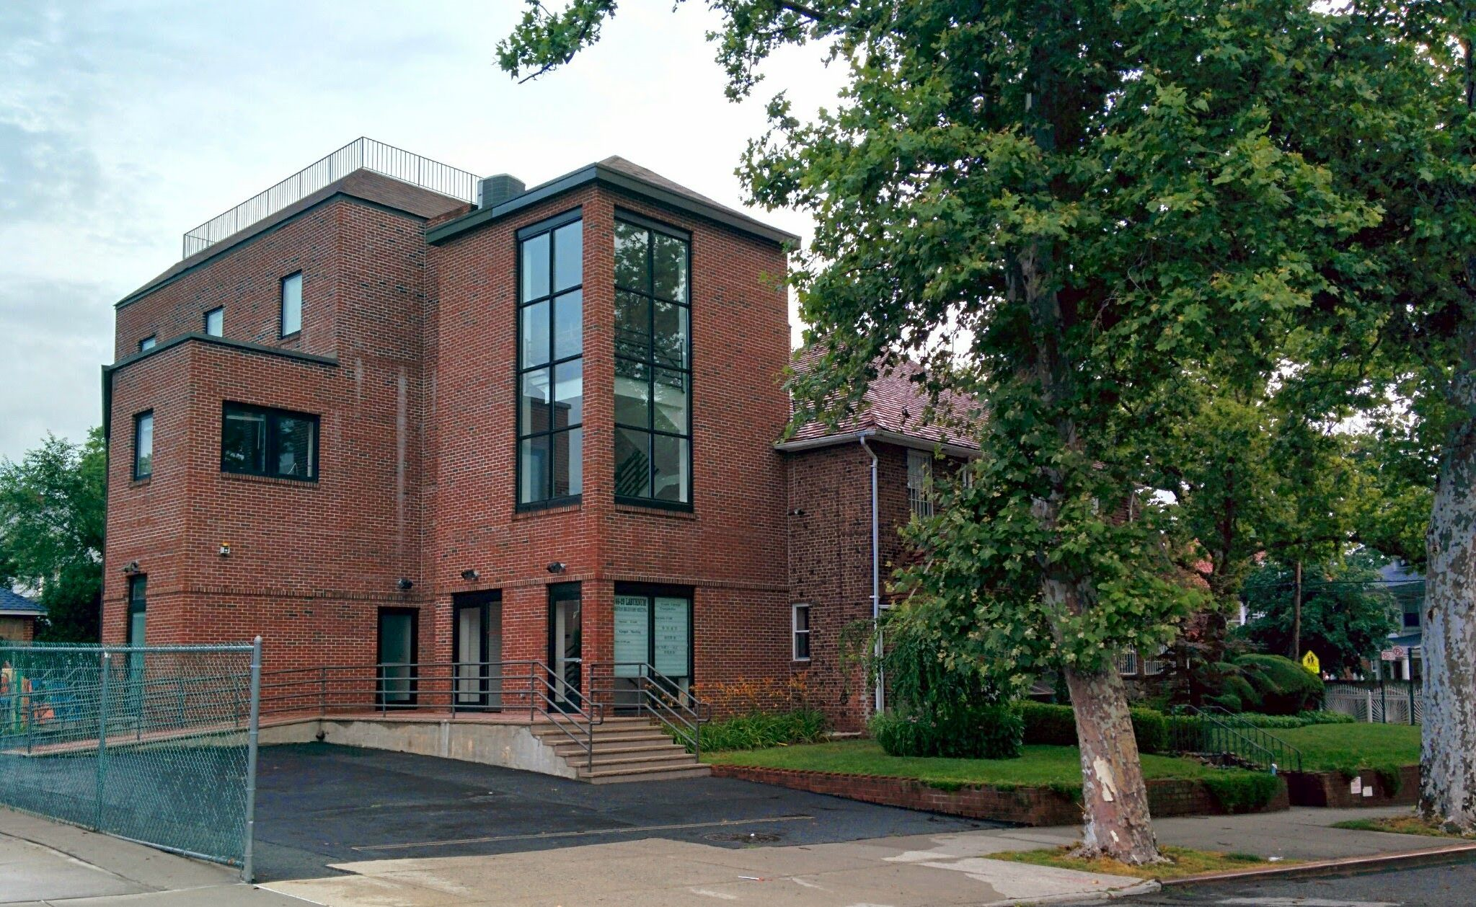

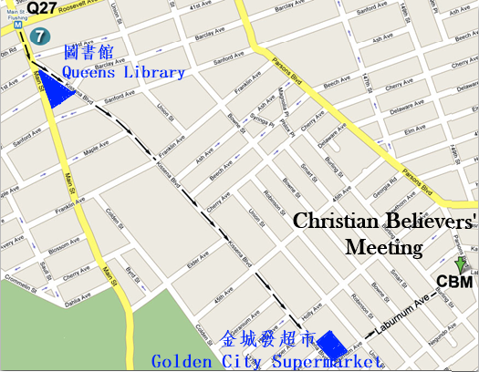

***Lift up your eyes, and look on the fields; for they are white already to harvest [John 4:35]***

***舉目向田觀看，莊稼已經熟了，可以收割了。  
 [約翰福音4:35]***

**2015 Fall Gospel Meeting in Flushing**

**法拉盛地區2015年秋季福音聚會**

***Time/日期: 10/4/2015, Sunday禮拜天上午11:00AM***

***Place/地點: Christian Believers’ Meeting***

***146-29 Laburnum Avenue,***

***Flushing, NY 11355  
Tel/電話: 516-234-0868***

**收割的時候到了！**

***全地正在有一個大收割***

“又有一位天使從殿中出來，向那坐在雲上的大聲喊著說：伸出你的鐮刀來收割；因為**收割**的時候已經到了，地上的莊稼已經熟透了。” [啟示錄 14:15]

***人種的是什麼收的就是什麼***

“不要自欺，　神是輕慢不得的。人**種**的是甚麼，**收**的也是甚麼。” [加拉太書6：7]

***種罪惡種子的，所收的是審判***

“**撒**罪孽的，必**收**災禍；他逞怒的杖也必廢掉。”  
 [箴言 22:8 ]

***悔改流淚而栽種的，必歡然神的收割***

“那**帶種**流淚出去的，必要歡歡樂樂地**帶禾捆**回來！”

[詩篇126:6]

***收割来了。罪的夏季已過，您得救了麼？***

“**麥秋**已過,夏令已完,我們還未**得救**!”[耶利米書8:20]