Our lives on earth are so very short. His salvation is so near.
Faith is very near
But what does it say? “THE WORD IS NEAR YOU, IN YOUR MOUTH AND IN YOUR HEART” — that is, the word of faith which we are preaching, Romans 10.8

His Kingdom is very near
“Repent, for the kingdom of heaven is near.” Matthew 3.2
Salvation is very near
Do this, knowing the time, for now salvation is nearer than when we first believed. Romans 13.11

Draw near to God through Jesus and be saved
Therefore He is able also to save forever those who draw near to God through Him. Hebrews 7.25

The end is near
The end of all things is near; therefore, be of sound judgment and sober spirit for the purpose of prayer. 1 Peter 4.7

How near are you to Paradise?
您離樂園有多近？
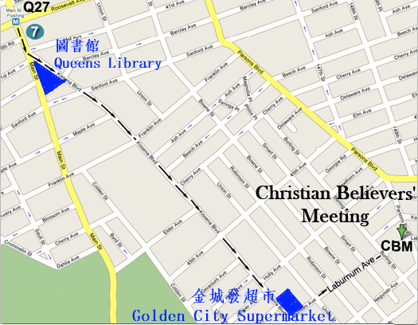
And He [Jesus] said to him, “Truly I say to you, today you shall be with Me in Paradise.” - Luke 23.43
耶穌對他說：我實在告訴你，今日你要同我在樂園裡了。路加福音23:43
2013 Fall Gospel Meeting in Flushing
法拉盛地區2013年秋季福音聚會

Time/日期: 2013-10-27, Sunday禮拜天上午11:00AM
Place/地點: Christian Believers’ Meeting
146-29 Laburnum Avenue,
Flushing, NY 11355
Tel/電話: 516-234-0868
我們地上的生命是何等短促，
他的救恩何等的近！
信心是非常近
他到底怎麼說呢？他說：這道離你不遠，正在你口裡，在你心裡。就是我們所傳信主的道。 羅馬書10章8節
他的國度是非常近
「天國近了，你們應當悔改！」 馬太福音3章2節
救恩是非常近
再者，你們曉得現今就是該趁早睡醒的時候；因為我們得救，現今比初信的時候更近了。 羅馬書13章11節
通過耶穌親近神得救
凡靠著他進到神面前的人，他都能拯救到底；因為他是長遠活著，替他們祈求。 希伯來書7章25節
結局近了
萬物的結局近了。所以，你們要謹慎自守，儆醒禱告。
彼得前書4章7節



