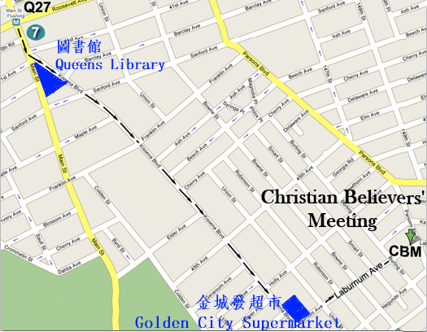
耶穌說：我是！
他是你永遠所有的需要。
法拉盛地區2011年夏季福音聚會

Time/日期: 2011-7-24, Sunday禮拜天上午11:00AM
Place/地點: Christian Believers’ Meeting
146-29 Laburnum Avenue,
Flushing, NY 11355
Tel/電話: 516-234-0868
耶穌說：我是！
他是你永遠所有的需要。
你是否觉得心中的空虚无法满足？
耶穌說，“我是生命的糧。”
你是否心靈乾渴？
耶穌說：“我將成為你生命中活水的泉源。”
你是否畏懼死亡？
耶穌說：“我是復活和生命。”
你是否疲倦和不堪重負？
耶穌說，“我將是你的安息。”
你是否對生活感到困惑，不知道你的方向？
耶穌說，“我就是道路，真理，生命。”
你是否發現你在黑暗中不知生活為了什麼呢？
耶穌說，“我是世界的光。”
Jesus is the “I am.” He is all that you will ever need.
2011 Summer Gospel Meeting in Flushing
Jesus is the “I am.”
He is all that you will ever need.
Are you spiritually hungry?
He said, “I am the bread of life.”
Are you thirsty for something more satisfying in your life?
He said, “I will be a well of water for you.”
Are you afraid of death?
He said, “I am the resurrection and the life.”
Are you weary and heavy-burdened?
He said, “I will be your rest.”
Are you confused about life and don't know your way?
He said, “I am the way, the truth, and the life.”
Do you find you are in the dark about what life is about?
He said, “I am the light of the world.”


