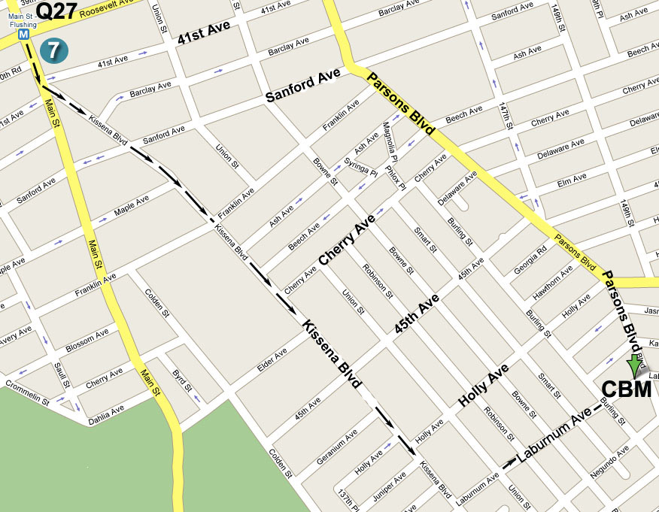

指南: 若從七號地鐵終點站往圖書館方向沿Kissena Blvd.
行至王朝豪庭大酒樓左轉入Laburnum Ave., 再前行五
個街口即Parsons Blvd., 路口左邊第一棟高樓

Directions: Take the No. 7 train to Main Street, Flushing.
Walk south to the Flushing Library and bear left onto Kissena Blvd.
Then make a left turn onto Laburnum Ave (after Golden City
Supermarket). The building will be down the street on your left, at
the corner of Parsons Blvd. and Laburnum Ave.

公車(By Bus): Q17 to Laburnum Ave. or (或) Q27 to Parsons Blvd.

耶稣说:“我就是道路，真理，生命。 若不藉着我，没有人能到父那里去。”
(約翰福音14章6節) Jesus said: “I am the way, the truth, and the life, no one
can come to the Father but through Me.” (John 14:6)

除祂 (耶稣)以外，别无拯救。因为在天下人间，没有赐下别的名，我们可以
靠着得救。(使徒行傳4章12節) And in none other (except in Jesus Christ) is
there salvation: for neither is there any other name under heaven, that is given
among men, wherein we must be saved. (Acts 4: 12)
歡迎參加 Please Come and Join Us
法拉盛地區
2009年夏季福音聚會
2009 Summer Season

Special Gospel Meeting
You are invited to come and hear the Good News!!

Date (日期): Sunday, June 21, 2009 at 11:00 AM
2009年6月21日, 禮拜天上午11點整

Place (地點): Christian Believers’ Meeting
146-29 Laburnum Avenue (corner of Parsons
Blvd.), Flushing, NY 11355

Tel (電話): 718-886-7988 or (或) 516-932-0539

耶和華說: “我知道我向你們所懷的意念、是賜平安的意念、不是降災禍的意念、要叫你們末後有指望。” (耶利米書29章11節)
For I know the thoughts that I think toward you, says the LORD, thoughts of peace, and not of evil, to give you in your latter end a hope. (Jeremiah 29:11)

“再一次我不單要震動地、還要震動天。 這再一次的話, 是指明被震動的, 就是受造之物, 都要挪去, 使那不被震動的常存. ” (希伯來書12章26-27節)
Yet once more will I make to tremble not the earth only, but also the heaven. But this Yet once, signifies the removing of what is shaken, as being made, that what is not shaken may remain. (Hebrews 12:26-27)

大山可以挪開、小山可以遷移．但我的慈愛必不離開你、我平安的約也不遷移．這是憐恤你的耶和華說的。 (以賽亞書54章10節)
For the mountains may depart, and the hills be removed; but my loving-kindness shall not depart from you, neither shall my covenant of peace be removed, says Jehovah who has mercy on you. (Isaiah 54:10)

– Give Me Thy Heart –

God’s word has told us: “For where your treasure is, there will your heart be also.” (Matthew 6: 21)

Proverbs, the wisdom book of the Bible, also said: “Guard your heart with all diligence, for from it flows the spring of life.” (Proverbs 4:23)

Dear friends, where is your heart now?
In whom will your heart trust among the great multitudes in this fleeting life?
Who or what has ownership of your heart?

Confronted with frequent natural and man-made disasters, do you still have peace in your heart? Under the threats of an all-consuming nuclear holocaust, do you truly have assurance?

Every outward sign affirms to us that the world is speeding toward its end. From the virulent strains of “superbug”, disruptive global climate change, to the murderous scheme of extreme terrorists, and destabilizing financial crisis, everything reminds us that our world is buckling under all manner of pressure.

“The end of all things is at hand.” (1 Peter 4:7) Dark clouds looms over the future of humanity, how shall we find a way of escape?

Yet, it is not the intention of our loving God to see mankind suffers, since we were created in His image and likeness. Rather, He bids us to give our hearts to Him as He alone possesses the spring of life abundant.

For this reason, two thousand years ago, He sent His only beloved Son – Jesus Christ – to come into this world as a divinely appointed sacrifice for all lost sinners. There on the cross the sin-barrier between God and man was broken so that now man may partake in what is life indeed. Everything has been prepared for man, even as God openly poured out His love at that cruel cross.

What alone is necessary for you now, my friend, is to trust in His unfailing love for you and to respond by humbly accepting His gift of love to you. What He seeks is simply an exchange of love, simply an exchange of the hearts.

God desires your love even as He loves you intensely.

My son, give me your heart; And let your eyes delight in my ways. Proverbs 23:26

To you who do not know this man named Jesus,
You've never lived or found life's greatest joy;
Oh, won't you now take Him as Lord and Savior,
And know the fullness of His matchless love?
- 將心給我 -

聖經上神的話告訴我們: “你的財寶在哪裏, 你的心也在那裏.”
在聖經上的箴言智慧篇上又有一處說:
“你要保守你心, 勝過保守一切, 因為一生的果效, 是由心發出。”

親愛的朋友, 此時此刻, 您的心在哪里?
在這茫茫的人海中, 在轉瞬即逝的歲月里, 您將您的心歸向誰呢?
是誰掌管您心靈的鑰匙? 究竟哪里是您心靈的家鄉?

面臨頻頻的天災人禍, 您心靈的深處有平安嗎?
在躍躍欲試的核子威脅之下, 您心中還有把握嗎?
更有: 駭人的恐怖分子正蠢蠢欲動、人在可怕的瘟疫面前束手無策,
百年老店瀕臨破產, 經濟風暴愈演愈烈,
世界面臨能源危机, 全球變暖迫在眉捷,
在這一切末世的征兆之前, 您內心深處仍然有盼望嗎?

在這一切人類可怕蔭霾之下,
誰有能力面對? 誰有能力擺脫? 誰又有能力和智慧去解決?
其實, 這一切的發生, 正應驗了聖經上神的話: “萬物的結局近了!”

但神的心意并不是要懲罰按照祂自己的形象和樣式所造的人,
神乃是要我們的心轉向祂, 將我們的心歸給祂.
神差遣祂的獨生愛子耶穌基督降世, 成為替罪的羔羊,
在十字架上, 神的儿子為你我捨性命流寶血, 祂的心為你我而破碎!
神的儿子為何受死? 乃是為了將祂的心敞開給你和我!
但是死并不能拘禁祂, 因祂巳成全了救贖, 從死里复活,
并升天坐在父神寶座的右邊! 神巳立耶穌作全人類的救主!

親愛的朋友, 請听無數神的儿女的經歷、見証、和勸勉:
你也許並不知道誰是耶穌，你還沒享受人生的最樂;
阿你能否接受祂作你救主，領受祂豐盛無量的恩典?

親愛的朋友, 您遇見主了嗎? 您是否愿意今天就將心給主?

我兒、要將你的心歸我; 你的眼目, 也要喜悅我的道路. (箴言23 章26節)

