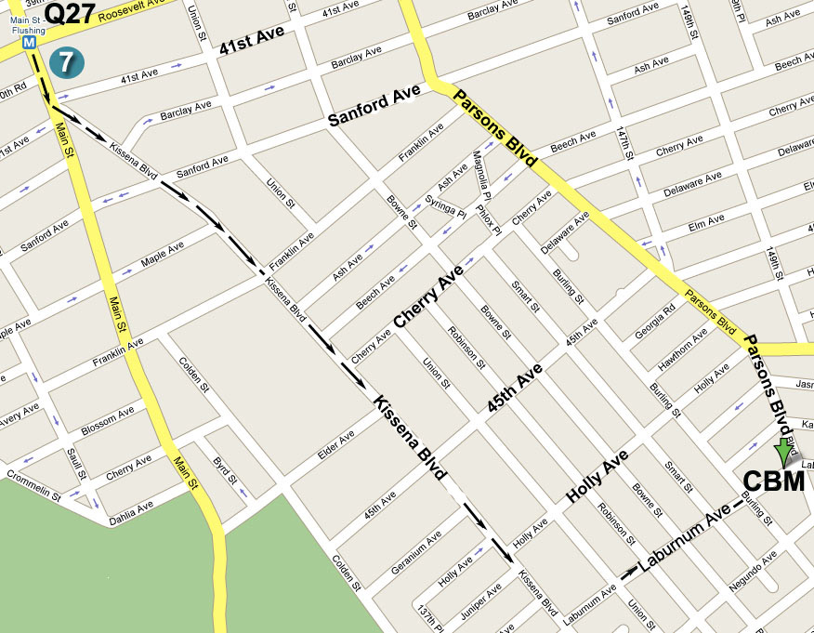

指南: 若從七號地鐵終點站往圖書館方向沿Kissena Blvd.
行至王朝豪庭大酒樓左轉入Laburnum Ave., 再前行五
個街口即Parsons Blvd., 路口左邊第一棟高樓

Directions: Take the No. 7 train to Main Street, Flushing.
Walk south to the Flushing Library and bear left onto Kissena Blvd.
Then make a left turn onto Laburnum Ave (after Golden City
Supermarket). The building will be down the street on your left, at
the corner of Parsons Blvd. and Laburnum Ave.

公車(By Bus): Q17 to Laburnum Ave. or (或) Q27 to Parsons Blvd.

耶稣说:“我就是道路，真理，生命。 若不藉着我，没有人能到父那里去。” (約翰福音14章6節) Jesus said: “I am the way, the truth, and the life, no one can come to the Father but through Me.” (John 14:6)

除祂 (耶稣)以外，别无拯救。因为在天下人间，没有赐下别的名，我们可以靠着得救。(使徒行傳4章12節) And in none other (except in Jesus Christ) is there salvation: for neither is there any other name under heaven, that is given among men, wherein we must be saved. (Acts 4: 12)
歡迎參加 Please Come and Join Us
法拉盛地區
2008年年終福音聚會
2008 Year End

Special Gospel Meeting
You are invited to come and hear the Good News!!

Date (日期): Thursday, December 25, 2008 at 4:00 PM
2008年12月25日, 禮拜四下午4點整
Love Feast at 6:00 PM, 愛筵: 晚上六點

Speaker (講員): Christian Chen (陳希曾弟兄)

Place (地點): Christian Believers’ Meeting
146-29 Laburnum Avenue (corner of Parsons
Blvd.), Flushing, NY 11355

Tel (電話): 718-886-7988 or (或) 516-932-0539

神 的 事 情 、 人 所 能 知 道 的 、 原 顯 明 在 人 心 裡. 因 為 神 已 經 給 他 們 顯 明 。自从造天地以来， 神的永能和 神性是明明可知的，虽是眼不能见，但藉着所造之物，就可以晓得，叫人无可推诿。(羅馬書1章19-20節)
Because that which is known of God is manifest in them; for God manifested it unto them. For the invisible things of Him since the creation of the world are clearly seen, being perceived through the things that are made, even His everlasting power and divinity; that they may be without excuse. (Romans 1: 19-20)

人 非 有 信 、 就 不 能 得 神 的 喜 悅 ． 因 為 到 神 面 前 來 的 人 , 必 須 信 有 神 ， 且 信 祂 賞 賜 那 尋 求 祂 的 人 。(希伯來書11章6節)
But without faith it is impossible to please Him: for he that comes to God must believe that He is, and that He is a rewarder of them that diligently seek Him. (Hebrews 11:6)
– Jesus Christ The Same Yesterday, today, and Forever –

God’s Word has told us: “In the last days perilous times shall come. For men shall be lovers of their own selves, covetous, boasters, proud, blasphemers, disobedient to parents, unthankful, unholy, without natural affection, trucebreakers, false accusers, incontinent, fierce, despisers of those that are good, traitors, heady, high-minded, lovers of pleasures more than lovers of God.” (2 Timothy 3:1-4)

When Jesus was talking on earth, He also warned His disciples about the end times: “For nation shall rise against nation, and kingdom against kingdom; and there shall be famines and earthquakes in diverse places. But all these things are the beginning of travail.” (Matthew 24:7-8)

God’s Word also told us: “Yet once will I shake not only the earth, but also the heaven. But this Yet once, signifies the removing of what is shaken, as being made, that what is not shaken may remain.” (Hebrews 12:26-27)

Looking at the current world situation, we cannot but sense the uncertainty of future,
the hidden dangers at all corners, the shadow of ever present terrorism threat, the billows of economical crisis, the failing energy resources, the global warming, and so on. All these just fulfill what was written in God’s Word: “The end of all things is drawing nigh!” (1 Peter 4:7)

Dear friends, as you face the uncertainty of life, you may wonder:
Where is my home on this earth? How could I gain rest for my soul?

Thanks be to God, we know that God is leading His children through all the stormy blasts. Many things may change, but Jesus Christ is the Rock of Ages.
Jesus Christ is the same yesterday, today, and forever! (Hebrews 13:8)

When it is darkness all around us, there is still light in the house of God! Since Jesus said: “I am the light of the world; he that follows me shall not walk in darkness, but shall have the light of life.” (John 8:12)
When there is a spiritual famine around us, there are still abundant bread of life in God’s household, since Jesus also said: “I am the bread of life: he that comes to Me shall never hunger, and he that believes on Me shall never thirst at any time.” (John 6:35)
When everyone is greatly shaken, as God’s children we still have everlasting peace and joy from heaven, since Jesus has told us: “Come to me, all you who labor and are burdened, and I will give you rest.” (Matthew 11:28)
When sufferings are found everywhere, as God’s children we can overcome them, since Jesus said: “In the world ye have tribulation; but be of good courage: I have overcome the world.” (John 16:33)

Dear friends, why don’t you draw nigh to the Son of God, who went to the Cross and paid the penalty of sin for all mankind, including you and me. As God Word told us: “The chastisement of our peace was upon him, and with his stripes we are healed.” He that believes on him shall not be put to shame. Dear friends, in this short and fleeting life, how can you ignore such a great salvation of your soul?!

“If therefore the Son shall make you free, you shall be free indeed.” (John 8:36)
-耶穌基督昨日今日直到永遠永不改變-

神的話告訴我們: “因為那時人要專顧自己、貪愛錢財、自誇、狂傲、謗讟、違背父母、忘恩負義、心不聖潔、無親情、不解怨、好說讒言、不能自約、性情兇暴、不愛良善、賣主賣友、任意妄為、自高自大、
愛宴樂、不愛神.”
耶穌基督在地上行走時也曾警告過祂門徒說, 在末期時:
“民要攻打民, 國要攻打國. 多處必有饑荒,地震. 這都是產難的起頭.”
神的話又告訴我們:“再一次我不單要震動地,還要震動天. 這再一次的話, 是指明被震動的, 就是受造之物都要挪去, 使那不被震動的常存.”

綜觀現今的世界, 真是人心惶惶、危机四伏, 恐怖陰影籠罩人心,
面臨一波又一波的金融風暴, 動盪不安的世局, 能源衰竭, 全球變暖,
這一切正應驗了聖經上神所說的話: “萬物的結局近了!”
親愛的朋友, 這世界何處是你家? 您內心深處在何處可得著安息呢?

感謝神! 在這一切狂怒風潮中, 知道我們的神正在引領.
當萬事萬物都在改變的時候, 知道我們的神乃是萬古的磐石, 因為:
惟有耶穌基督昨日, 今日, 直到永遠, 永不改變!

當四圍都是黑暗的時候, 神的家 (教會)中仍然有燈光!
耶穌說:“我是世界的光。跟從我的、就不在黑暗裡走、必要得著生命的光.”
當四圍都有飢荒的時候, 神的家 (教會)中仍然有丰富的賜人生命之糧!
耶穌說:“我就是生命的糧。到我這里來的，必定不餓﹔信我的，永遠不渴.”
當四圍都惊惶的時候, 信靠神的人卻滿了喜樂平安! 因為耶穌基督曾說:
“凡勞苦擔重擔的人、可以到我這裡來、 我就使你們得安息 。”
當四圍充滿苦難的時候, 信靠耶穌的人可依靠神胜過苦難!
耶穌說:“ 在世上你們有苦難, 但你們可以放心, 我巳經勝了世界.”

來吧! 讓我們來就近神的愛子, 因為就在兩千年前, 在十字架上,
耶穌基督為全人類的罪巳經受了刑罰. 因祂的鞭傷, 我們蒙醫治;
因祂的刑罰, 我們得了平安. 信靠祂的人必不至羞愧, 也不至著急!
親愛的朋友, 人生短暫, 轉瞬即逝, 只有一次. 在神的面前, 在這關鍵的時刻和於您至關重要的靈魂要得蒙救贖的事上, 您當作何樣的選擇呢?

“ 天父的儿子若叫你們自由, 你們就真自由了.”(約翰福音8 章36 節)

