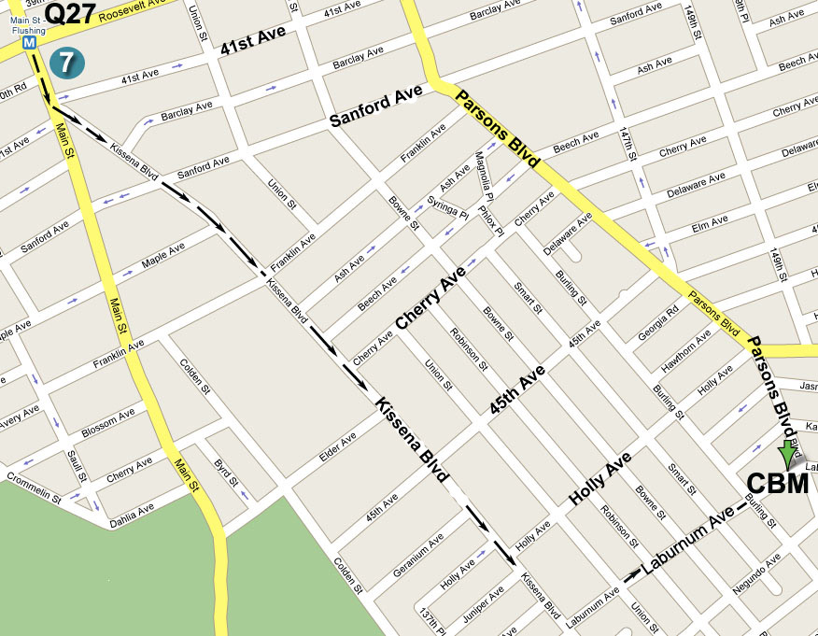

指南: 若從七號地鐵終點站往圖書館方向沿Kissena Blvd.
行至王朝豪庭大酒樓左轉入Laburnum Ave., 再前行五
個街口即Parsons Blvd., 路口左邊第一棟高樓

Directions: Take the No. 7 train to Main Street, Flushing.
Walk south to the Flushing Library and bear left onto Kissena Blvd. Then make a left turn onto Laburnum
Ave (after Golden City Supermarket). The building
will be down the street on your left, at the corner of
Parsons Blvd. and Laburnum Ave.

公車(By Bus): Q17 to Laburnum Ave. or Q27 to Parsons Blvd.

耶稣说:“我就是道路，真理，生命。 若不藉着我，没有人能到父那里去。” (約翰福音14章6節) Jesus said: “I am the way, the truth, and the life, no one can come to the Father but through Me.” (John 14:6)

耶和华阿，因此我要在外邦中称谢你，歌颂你的名。(撒下22章50節) Therefore will I give thanks to You, O Lord, among the nations, and will sing psalms to Your name. (2 Samuel 22: 50)
歡迎參加 Please Come and Join Us
法拉盛地區
2008年感恩福音聚會
2008 Thanksgiving Day

Special Gospel Meeting
You are invited to come and hear the Good News!!

Date (日期): Thursday, November 27, 2008 at 4:00 PM
2008年11月27日, 禮拜四下午4點整
Thanksgiving dinner at 6:30 PM
感恩愛筵: 晚上六點半

Place (地點): Christian Believers’ Meeting
146-29 Laburnum Avenue (corner of Parsons
Blvd.), Flushing, NY 11355

Tel (電話): 718-886-7988 or (或) 516-932-0539

普天下當向耶和华歡呼。你們當樂意事奉耶和华。
當來向祂歌唱。你們當曉得耶和华是神。
我們是祂造的，也是属祂的。我們是祂的民，也是祂草场的羊。
當稱謝進入祂的門，當贊美进入祂的院。當感謝祂稱頌祂的名。
因為耶和华本為善，祂的慈愛，存到永遠，祂的信實，直到萬代。
(詩篇第100篇)

Shout aloud unto the LORD, all the earth!
Serve the LORD with joy: come before His presence with singing.
Know you that the Lord, He is God: It is He that has made us,
And we are His; We are His people, and the sheep of His pasture.
Enter into His gates with thanksgiving, and into His courts with praise:
Be thankful unto Him, and bless His name.
For the LORD is good; His mercy is everlasting;
And His truth endures to all generations. (Psalms 100)

– In Everything Give Thanks –

Why should we give thanks in everything?
“For this is the will of God in Christ Jesus concerning us.” (1 Thessalonians 5:18)
Our God is all knowing, almighty, all wise, and all sufficient.
“He makes all things work together for good for those that love God,
to them who are the called according to His purpose.” (Romans 8:28)
For all of this we should give thanks!

There is an old saying in China:
"A drop received in need, will be repaid with a whole river."
But how much more God has given to man!
He sends the sunshine and the rain, He sends the harvest’s golden grain;
He even sent His own beloved Son, Jesus Christ, to come to this world,
who died on the cross in order to save sinners like you and me.
How much we need to give thanks!

God’s Word says: “Every good gift and every perfect gift comes down from above, from the Father of lights, with whom is no variation
nor shadow of turning.” (James 1:17)
For in Him we live, and move, and have our being. (Acts 17:28)
God’s beloved Son, Jesus, once exhorted His listeners:
“Behold the birds of the heaven, that they sow not, neither do they reap,
Nor gather into barns; and your heavenly Father feeds them.
Are not you of much more value then they?” (Matthew 6:26)
Indeed we have a loving heavenly Father who cares for us --
He even takes care of little sparrows!

Listen to the heavenly Good News:
“Seek first His kingdom and His righteousness,
and all these things (that you need) will be given to you as well” (Matthew 6:33)
“Man shall not live by bread alone,
but by every word that proceeds out of the mouth of God.” (Matthew 4:4)
Jesus told us, “If any man thirst, let him come unto Me and drink. (John 7:37) Whosoever drinks of the water that I shall give him shall never thirst; but the water that I shall give him shall be in him a well of water springing up into everlasting life.” (John 4:14)
“I am the bread of life: he that comes to Me shall never hunger, and he that believes on Me shall never thirst at any time.” (John 6:35)
“Ask, and it shall be given to you. Seek, and you shall find.
Knock, and it shall be opened to you.” (Matthew 7:7)

Dear friends, as you face the uncertainty of life and the ever-changing world,
please remember:
Jesus Christ never changes. He is the same yesterday, today, and forever!
Let us join together to praise and thank our God, our Creator and Savior,
with songs and testimonies, and worship together Him in spirit and truth!

“Rejoice always; pray unceasingly; in everything give thanks, for this is will of God in Christ Jesus towards you.” (1 Thessalonians 5: 16-18)
-凡事謝恩 -

凡事謝恩? 為什么? 因為這是神對祂儿女所定的旨意.
因為我們的神是全知全能全智全丰的神. 祂使万事都相互效力,
為的是使愛神、尋求神的人來認識祂的恩典与大能并得著益處.
為此, 我們應當感恩!

中國有一成語:“滴水之恩, 湧泉相報.”而神賜人何止“滴水之恩”?
祂賜陽光, 又賜水流; 祂賜丰收, 金谷興旺.
衪甚至差遣祂的獨生愛子耶穌基督親自來到地上,
為了拯救人類脫离罪的捆綁和刑罰, 甘愿成為替罪的羔羊,
為全人類的罪, 而死在十字架上!
為此, 我們應當何等感恩!

神的話告訴我們: “各樣美善的恩賜和各樣全備的賞賜,
都是從上頭來的, 是從眾光之父那里降下來的.”
甚至我們的生命、動作、存留, 都在乎祂.
神的愛子耶穌曾對人說: “你們看天上的飛鳥, 也不种, 也不收,
你們的天父尚且養活它, 你們豈不比飛鳥貴重得多嗎?”
實在是的! 因為我們有一位慈愛的天父, 祂乃是那位看顧麻雀者.

聽啊, 這是天上來的佳音:
“你們要先求神的國和神的義, 這些(你們需用的)東西都要加給你們.”
“人活著不是單靠食物, 乃是靠神口里所出來的一切話.”
耶穌說: “人若渴了，可以到我這裡來喝. 人若喝我所赐的水，
就永远不渴。 我所赐的水，要在他里头成为源泉，直涌到永生.”
“我就是生命的糧。到我這里來的，必定不餓﹔信我的，永遠不渴。”
“你們祈求, 就給你們; 尋找, 就尋見; 叩門, 就給你們開門.”

親愛的朋友, 當環境動盪不安, 萬事萬物都在改變的時候, 讓我們記住:
惟有耶穌基督昨日, 今日, 直到永遠, 永不改變!
讓我們一同聚集, 用詩歌, 用見証, 用心靈誠實來向神感恩!

“ 常常喜樂, 不住的禱告, 凡事謝恩, 因為這是神在基督耶穌里向你們所定的旨意.” ( 帖撒羅尼迦前書第5 章第16 - 18 節)

