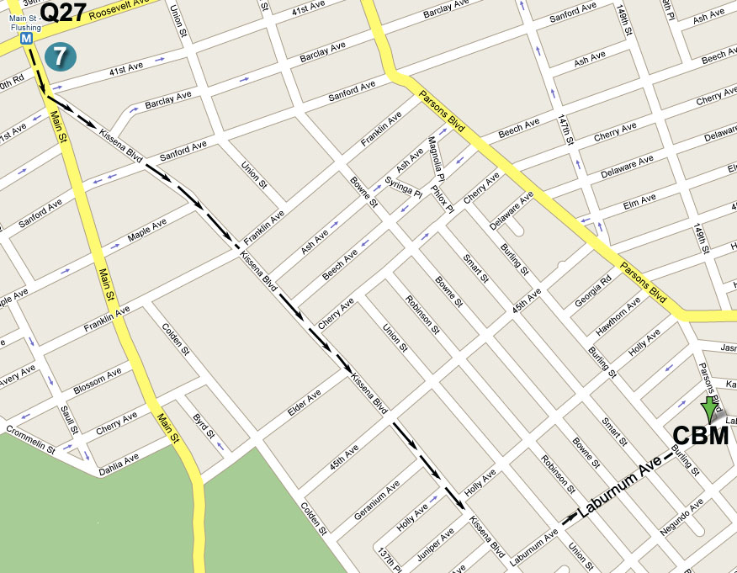

指南: 若從七號地鐵終點站往圖書館方向沿Kissena Blvd.
行至王朝豪庭大酒樓左轉入Laburnum Ave., 再前行五
個街口即Parsons Blvd., 路口左邊第一棟高樓

Directions: Take the No. 7 train to Main Street, Flushing.
Walk south to the Flushing Library and bear left onto Kissena Blvd. Then make a left turn onto Laburnum
Ave (after Golden City Supermarket). The building
will be down the street on your left, at the corner of
Parsons Blvd. and Laburnum Ave.

公車(By Bus): Q17 to Laburnum Ave. or Q27 to Parsons Blvd.

Jesus said: “I am the way, the truth, and the life, no one can come to the Father but through Me.” (John 14:6)
耶稣说:“我就是道路，真理，生命。若不藉着我，没有人能到父那里去。” (約翰福音14章6節)

歡迎參加 Please Come and Join Us
法拉盛地區
2008年秋季福音聚會
2008 Fall Season

Special Gospel Meeting
You are invited to come and hear the Good News!!

Date (日期): Sunday, September 14, 2008 at 11:00 AM
2008年9月14日, 禮拜天上午11時

Place (地點): Christian Believers’ Meeting
146-29 Laburnum Avenue (corner of Parsons
Blvd.), Flushing, NY 11355

Tel (電話): 718-886-7988 or (或) 516-932-0539

Jesus said: “In my Father's house are many mansions; if it were not so, I would have told you; for I go to prepare a place for you.” (John 14:2)
耶稣说:“在我父的家里，有许多住处。若是没有，我就早已告诉你们了。我去原是为你们预备地方去。”(約翰福音14章2節)

Jesus said: “Come to me, all you who labor and are burdened, and I will give you rest. (Matthew 11:28)
耶稣说:“凡劳苦担重担的人，可以到我这里来，我就使你们得安息。” (马太福音11章28節)

– Coming Home! –

“Coming home!” What sweet and inviting words!
It is the calling of our loving heavenly Father!
In the beginning man was created by God according to His own image.
And then God placed man in the beautiful Garden of Eden – a paradise.

What a tragedy! Man, the masterpiece of God’s creation, was deceived by Satan
and ate from the forbidden tree of the knowledge of good and evil.
As a result, man was ashamed to see God’s face and hid in bushes.
But the Bible story doesn’t end there! The heavenly Father went seeking and calling out to man: “Where are you?”

And ever since that time, God has been seeking man and preparing the way of salvation for lost sinners – a way of returning home. Do you know how He did this?
- He sent His only begotten Son – Jesus Christ - to become a man.
- On the cross, Jesus died for the sins of the whole human race.
- Christ opened up a new and living way back into the Father’s House.

Dear friends, have you sensed that this world is not your home?
The days of our earthly life are so short. Is there really nothing beyond this world?
The Bible says that Jesus Christ is preparing a glorious heavenly home for you.
It is a permanent, eternal, glorious city whose builder and maker is God.
Our heavenly Father even now is opening His arms to welcome you home when you come through the Door of His son Jesus Christ – He is the Only Way!

Dear friends, do you know where you came from and where you are going?
Do you fully realize the true meaning and value of your life?
Do you understand the eternal nature of your soul and its destiny?
Or are you still wandering without home, purpose or a heavenly Father?

Listen to the plea of Jesus, God’s beloved Son: “I’m on my way to get your room ready, I’ll come back and get you so you can live where I live.” (John 14:3)
Listen to the voice of the Spirit of God crying out: “Let the one who is thirsty come!”
(Rev. 22:17)
Listen to His voice in your heart! The heavenly Father is calling you by name and saying, “Please come home!”

Coming Home, why continue to wander?

“Believe on the Lord Jesus Christ, and you shall be saved, you and your household.” (Acts 16: 31)

- 回家吧! -

“回家吧!”這是何等親切又甜美的召喚,
您可否知道這正是慈愛的天父對您的呼召?
曾几何時, 神按照衪自己的形像和樣式造人,
并且把人安置在一個美麗無比的伊甸樂園里.

但何等可惜, 人卻受了蛇 (魔鬼撒但的化身) 的引誘,
吃了神吩咐不可吃的分別知識善惡樹上的果子,
因而躲藏在樹叢中, 不敢見神的面,
且聽天父第一次也是一直對人的尋找和召喚: “你在哪里？”

從那以后, 慈愛的天父一直在為失落的人預備救恩 - 一條回家的路.
就在兩千年前, 衪差遣祂的獨生愛子耶穌降世為人,
就在十字架上, 耶穌作為替罪的羔羊, 為全人類的罪而捨身,
在十字架上, 耶穌基督為我們開出一條又新又活的路, 直通到父的怀抱.

親愛的朋友，您是否知道這世界并非您的家, 我們在地上不過是客旅?
您是否曉得主耶穌在天上已經為您預備了一個榮美無比的家鄉?
您是否知道天父為我們經營并建造了一座有根基的光明天城?
您是否知道天父正伸開衪的雙臂, 整天巴望您回家?

親愛的朋友，您是否知道自己乃是按照神的形像和樣式所造?
您是否知道自己是從哪里來, 要往哪里去?
您是否明白您人生的真正意義与价值?
您是否了解您靈魂永遠的歸宿和它的寶貴?
您是否正遠离天父, 靈魂深處感覺好象在外面飄蕩?

聽啊, 這是天父的呼聲: “回家吧!”
聽啊, 這是神的愛子耶穌的宣告: “天國近了, 你們應當悔改!”
聽啊, 這是神聖善的靈的嘆息:“你们转回，转回吧！何必死亡呢?”

回家吧, 何必再流浪!

“当信主耶稣，你和你一家都必得救。” (使徒行传16章31節)

