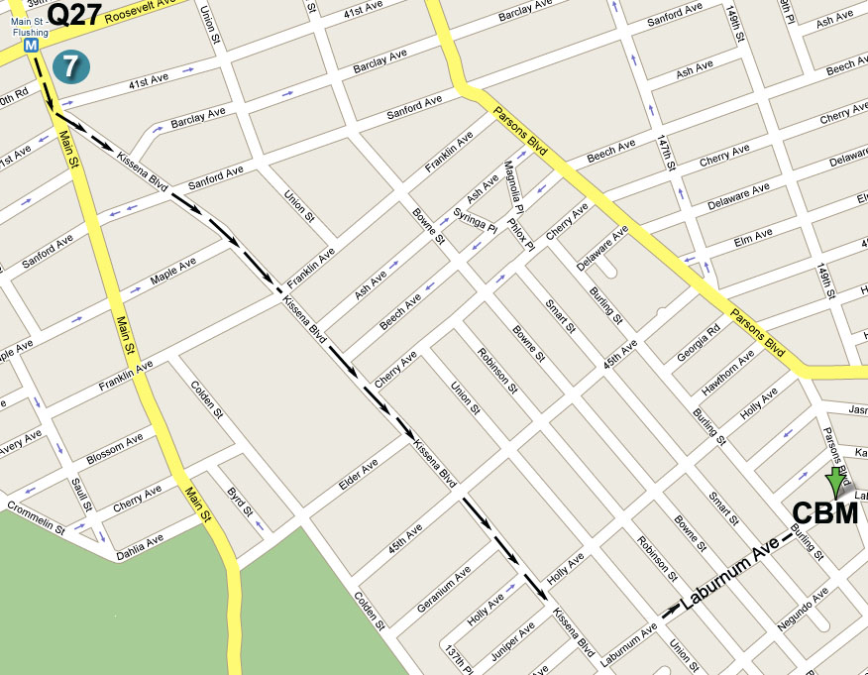

指南: 若從七號地鐵終點站往圖書館方向沿Kissena Blvd.
行至王朝豪庭大酒樓左轉入Laburnum Ave., 再前行五
個街口即Parsons Blvd., 路口左邊第一棟高樓

Directions: Take the No. 7 train to Main Street, Flushing.
Walk south to the Flushing Library and bear left onto Kissena Blvd. Then make a left turn onto Laburnum
Ave (after Golden City Supermarket). The building
will be down the street on your left, at the corner of
Parsons Blvd. and Laburnum Ave.

公車(By Bus): Q17 to Laburnum Ave. or Q27 to Parsons Blvd.

Jesus said: “I am the way, the truth, and the life, no one can come to the Father but through Me.” (John 14:6)
耶稣说:“我就是道路，真理，生命。若不藉着我，没有人能到父那里去。” (約翰福音第十四章第六節)
歡迎參加 Please Come and Join Us

法拉盛地區
2008年夏季福音聚會
2008 Summer Season

Special Gospel Meeting
You are invited to come and hear the Good News!!

Date (日期): Sunday, June 22, 2008 at 11:00 AM
2008年6月22日, 禮拜天上午11時

Place (地點): Christian Believers’ Meeting
146-29 Laburnum Avenue (corner of Parsons
Blvd.), Flushing, NY 11355

Tel (電話): 718-886-7988 or (或) 516-932-0539

For God so loved the world, that He gave His only begotten Son, that whosoever believes in Him should not perish, but have everlasting life. (John 3:16)
神愛世人、甚至將祂的獨生子賜給他們、叫一切信祂的、不至滅亡、反得永生。(約翰福音第三章第十六節)

And salvation is in none other (but Jesus Christ), for neither is there another name under heaven which is given among men by which we must be saved. (Acts 4:12)
除祂(耶稣基督)以外、別無拯救。因為在天下人間、沒有賜下別的名、我們可以靠著得救。 (使徒行傳第四章第十二節)
- Jesus Wept -

“Jesus Wept.” (John 11:35). Although this is the shortest verse in the Bible, it
reveals Jesus’ compassion for all mankind.
In another verse it tells us that Jesus “saw the crowds and had compassion for them, because they were worried and helpless, like sheep without a shepherd.” (Matthew 9:36)

Why did Jesus weep? He saw the tragedy of human life without God.
Again over an ancient city, Jesus wept as He cried out, “Jerusalem! Jerusalem!”, for He foresaw the tragic destruction of this great city by the Romans.

And what about today? Can you hear Jesus weeping after the terrorist attack on 9/11/01, or after the fatal earthquake in China on 5/12/08?
From the deadly Katrina hurricane in the southern U.S. to the recent cyclone in Burma’s triangle, can you discern Jesus’ sighs over the tragic state of mankind?

Yes, Jesus is weeping! Not only over the human tragedies but over the many victims dying without knowing either God or the way of salvation!

Our short life here on earth is meant to prepare us for eternity in God’s loving kingdom.

So Jesus wept in the garden of Gethsemane.
He wept for the whole world. He wept for mankind.
His tears were not for Himself, but for you and for me.

Jesus willingly died on the cross so that every man who believes in Him might have eternal life.

Dear friends, do you sense the deteriorating world situation, the economic recession, and the insecurity of life under the shadow of terrorist attacks?
Are you worried about global warming, nuclear threats, and the rising price of oil?
God truly has compassion for all of us.

Why don’t you turn to God’s Son Jesus Christ and find rest and protection under His mighty wings. Jesus Christ has risen from the dead, has cleansed your sins on the cross, and has been enthroned in heaven by God’s right hand!
Jesus Christ is the Savior of the world.
If you put your trust in Him, according to God’s promise, you shall be saved a
nd you shall be given everlasting life!

“The end of all things is drawing near.” (1 Peter 4:7a)
“Whosoever shall call upon the name of the Lord shall be saved.” (Romans 10:13)
- 耶穌哭了-

“耶穌哭了。” 這是聖經新約中一節最短的經文。
祂為什么而哭? 在十字架上, 衪曾大聲喊叫說:
“我的神, 我的神, 你為什么离棄我?”

耶穌也曾為一座古城哀哭: “耶路撒泠啊! 耶路撒泠啊!”
9.11, 5.12, 人禍天災中, 您是否听見耶穌的哭聲?
從美國南部的海嘯, 到最近緬甸境內的旋風,
您有否感覺到衪為人類的罪而發出的哀嘆悲鳴?

是的, 那是耶穌的哭聲! 在客西馬尼園, 為全世界, 為全人類。
祂哭并不是為自己, 乃是為我, 為你!
因祂的鞭傷, 我們得了醫治; 因祂所受的痛苦, 我們得了平安。

親愛的朋友，面對混亂的世局, 衰退的經濟, 恐怖的陰影,
您是否覺得前途茫茫, 不知所措?
親愛的朋友，面臨全球變暖, 核子威協, 油价飙升,
您有否會望洋興嘆, 失望灰心?
您是否愿意轉向救主耶穌, 在祂這萬古的磐石穴中得著庇護和幫助?

耶穌已經從死里复活, 衪要把我們的眼淚變成歡笑, 麻衣變作跳舞。
因衪巳經除盡罪惡, 胜過死亡, 升上高天, 并登上寶座!

耶穌基督乃是世上的光, 祂是明亮的晨星, 是谷中的百合花。
祂是神榮耀所發的光輝, 祂更是全人類的救主。
您若信靠衪必然得救, 并蒙神恩賜永遠的新生命。

“ 万物的结局近了。” (彼得前书 4章7節)
“凡呼求主名的，就必得救。” (罗马书十章13節)

